Name：Eman Fatima
Reg No: BSSE-23S-0025
Program: BSSE
Date: August 27th, 2026

WEEK NO. 2-

PART A: C# INTERMEDIATE BASICS

Exercises:-

Create a Generic Helper Method
Code:
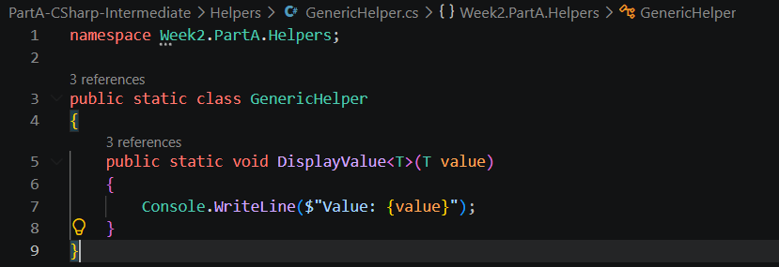
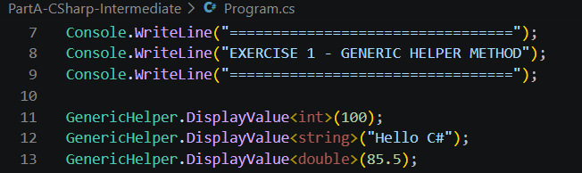
Output:
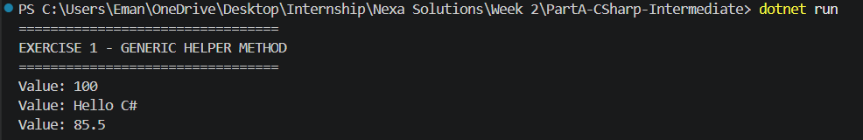

Create an Interface with Two Implementations
Code:
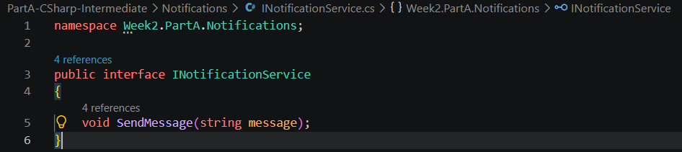
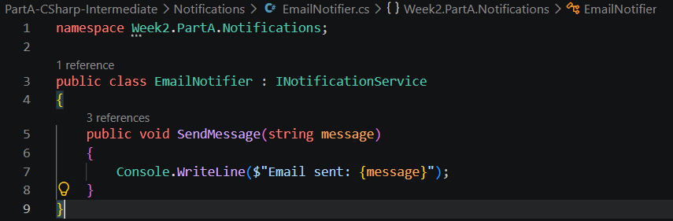
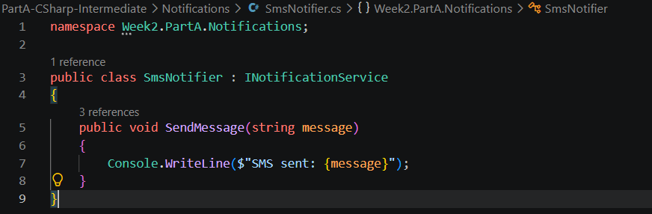
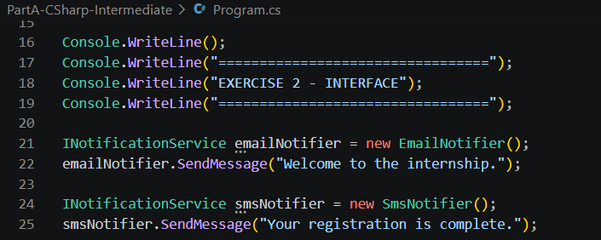
Output:
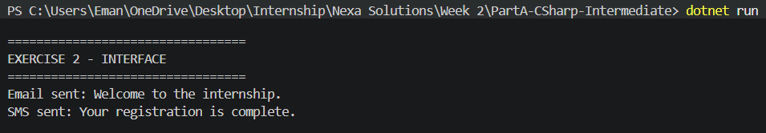

Write an Async Method That Waits and Returns a Result
Code:
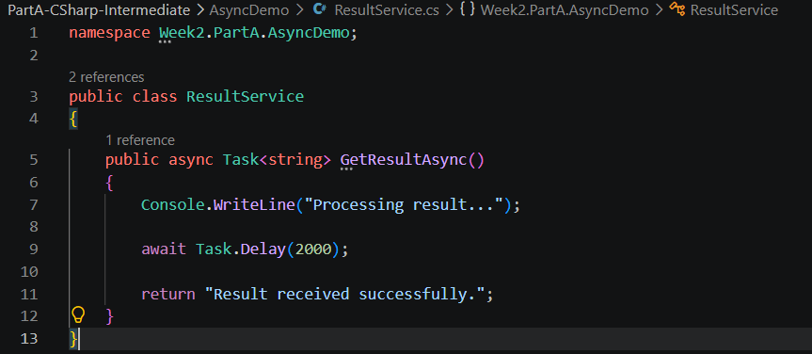
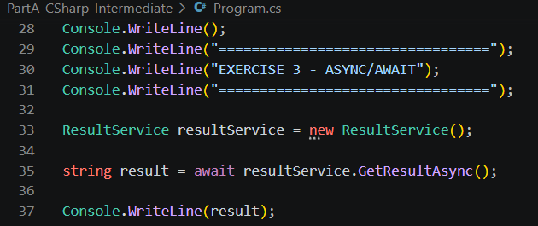
Output:
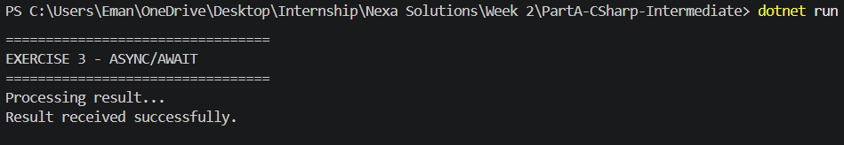

Refactor a Messy Console Program into Smaller Methods/Classes
Code:
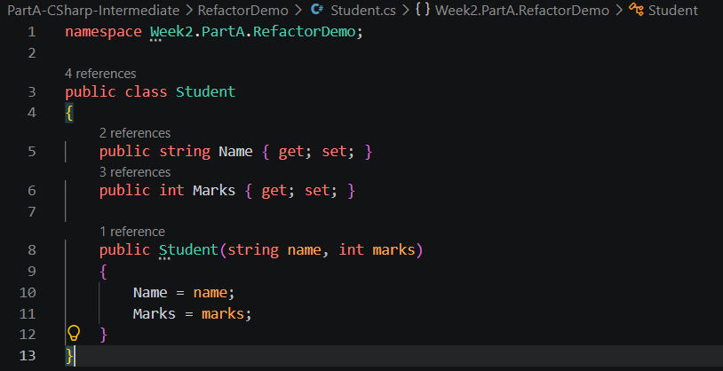
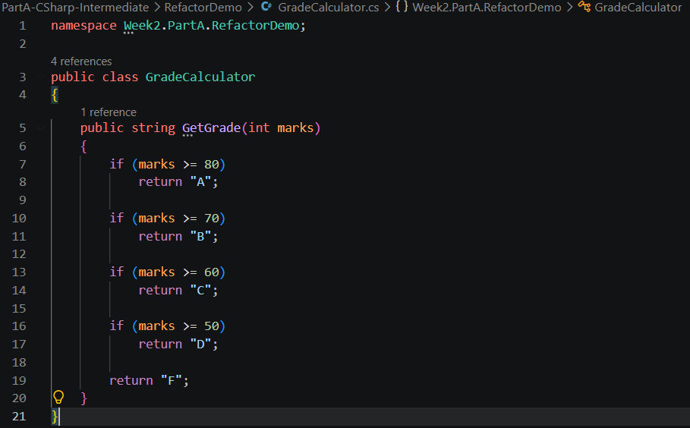
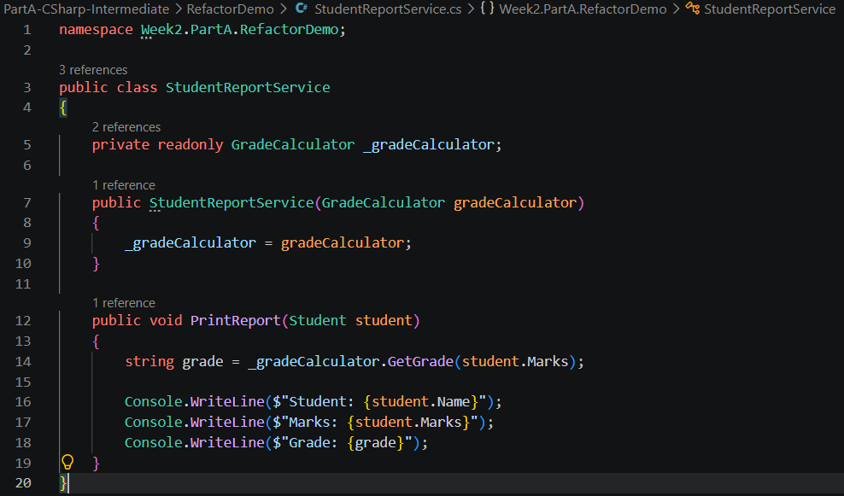
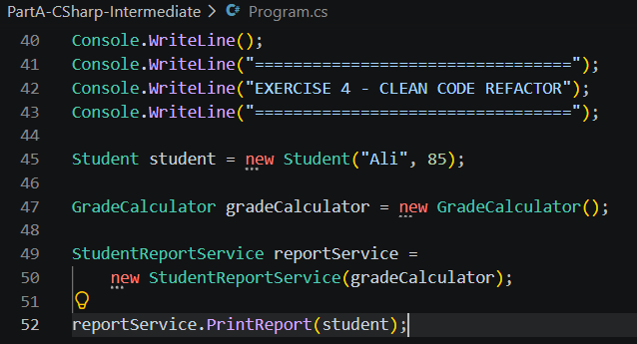
Output:
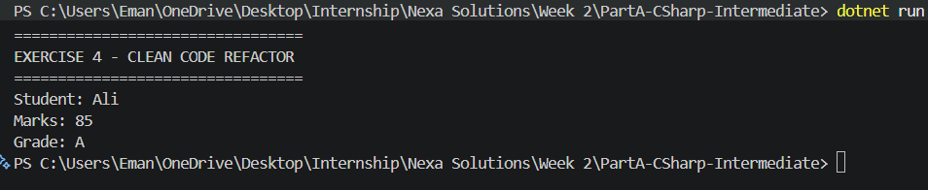

PART B: ASP.NET CORE FUNDAMENTALS

Exercises:-

Create an ASP.NET Core API With One GET Endpoint
Code:
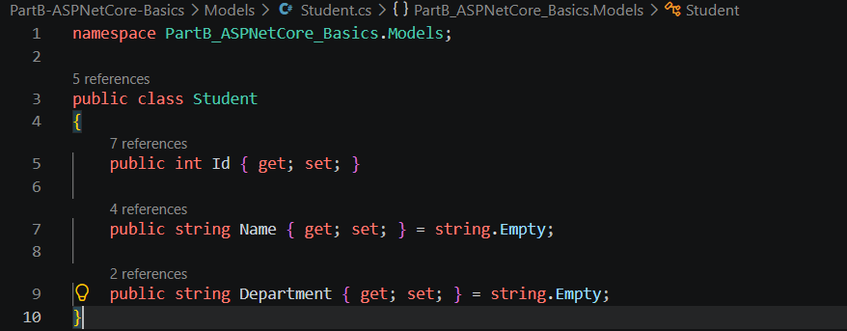
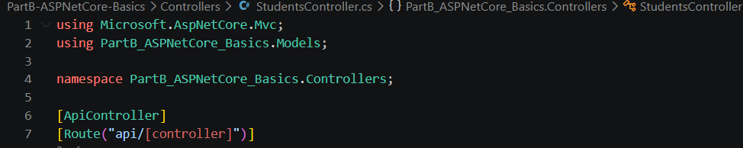
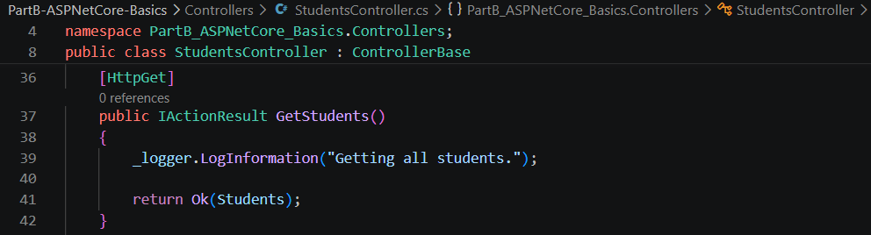
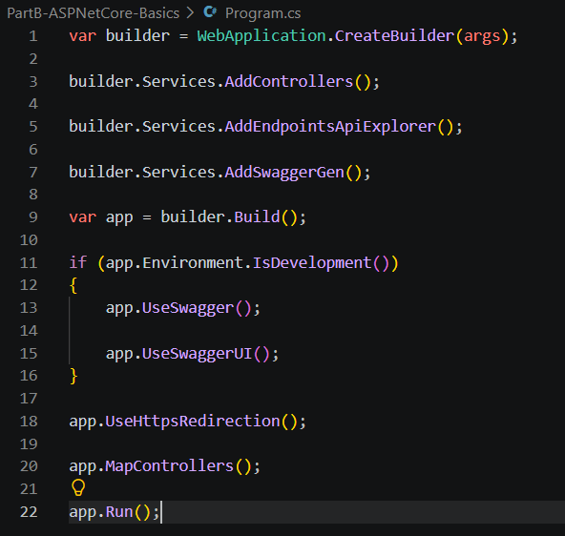
Output:
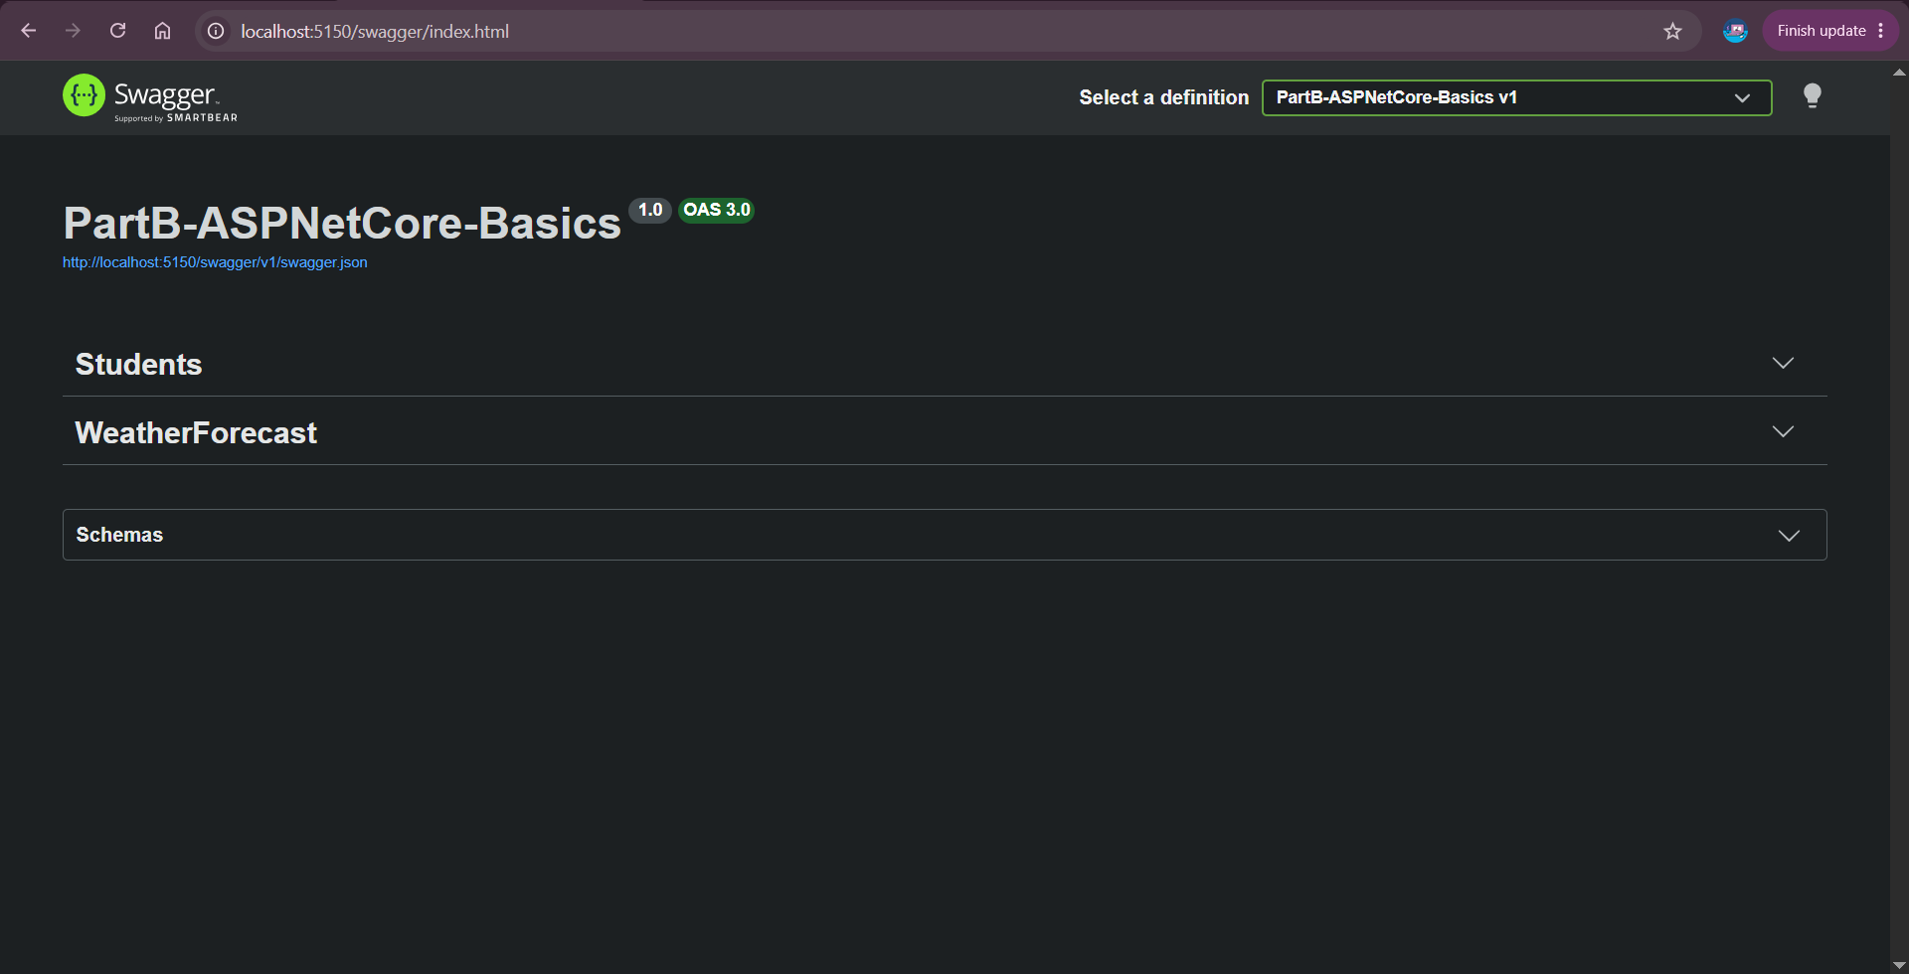
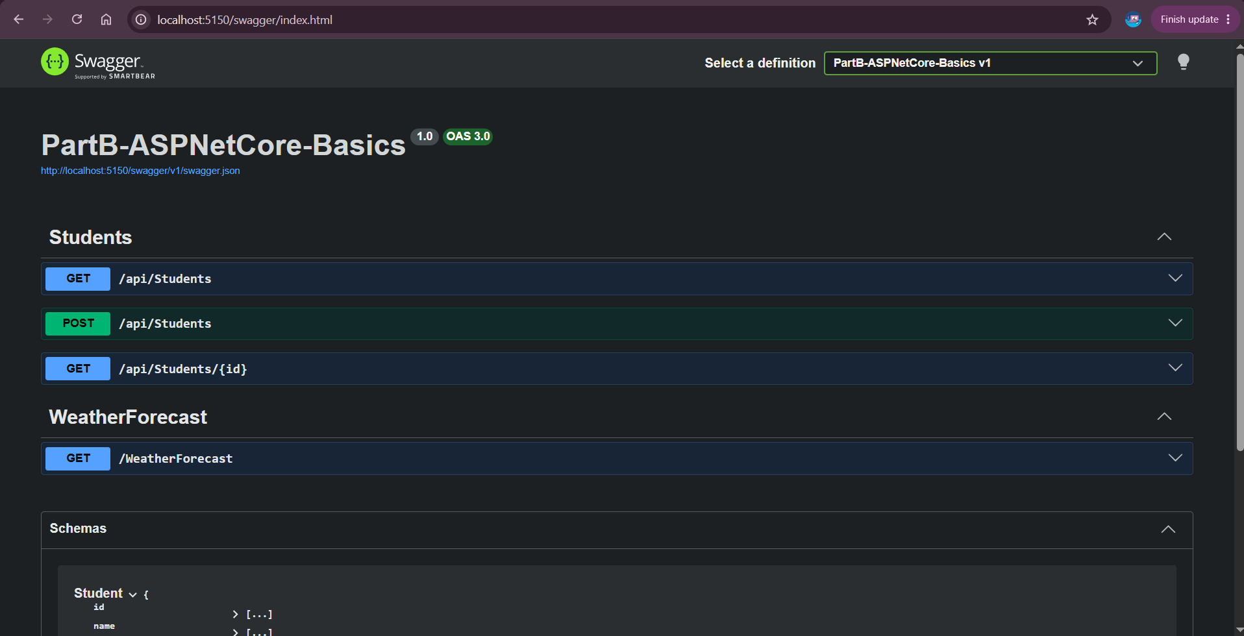
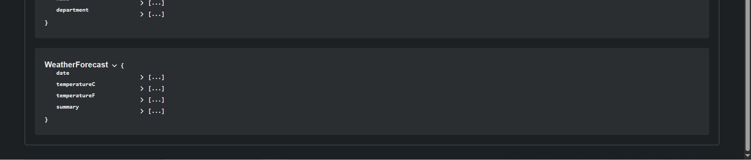
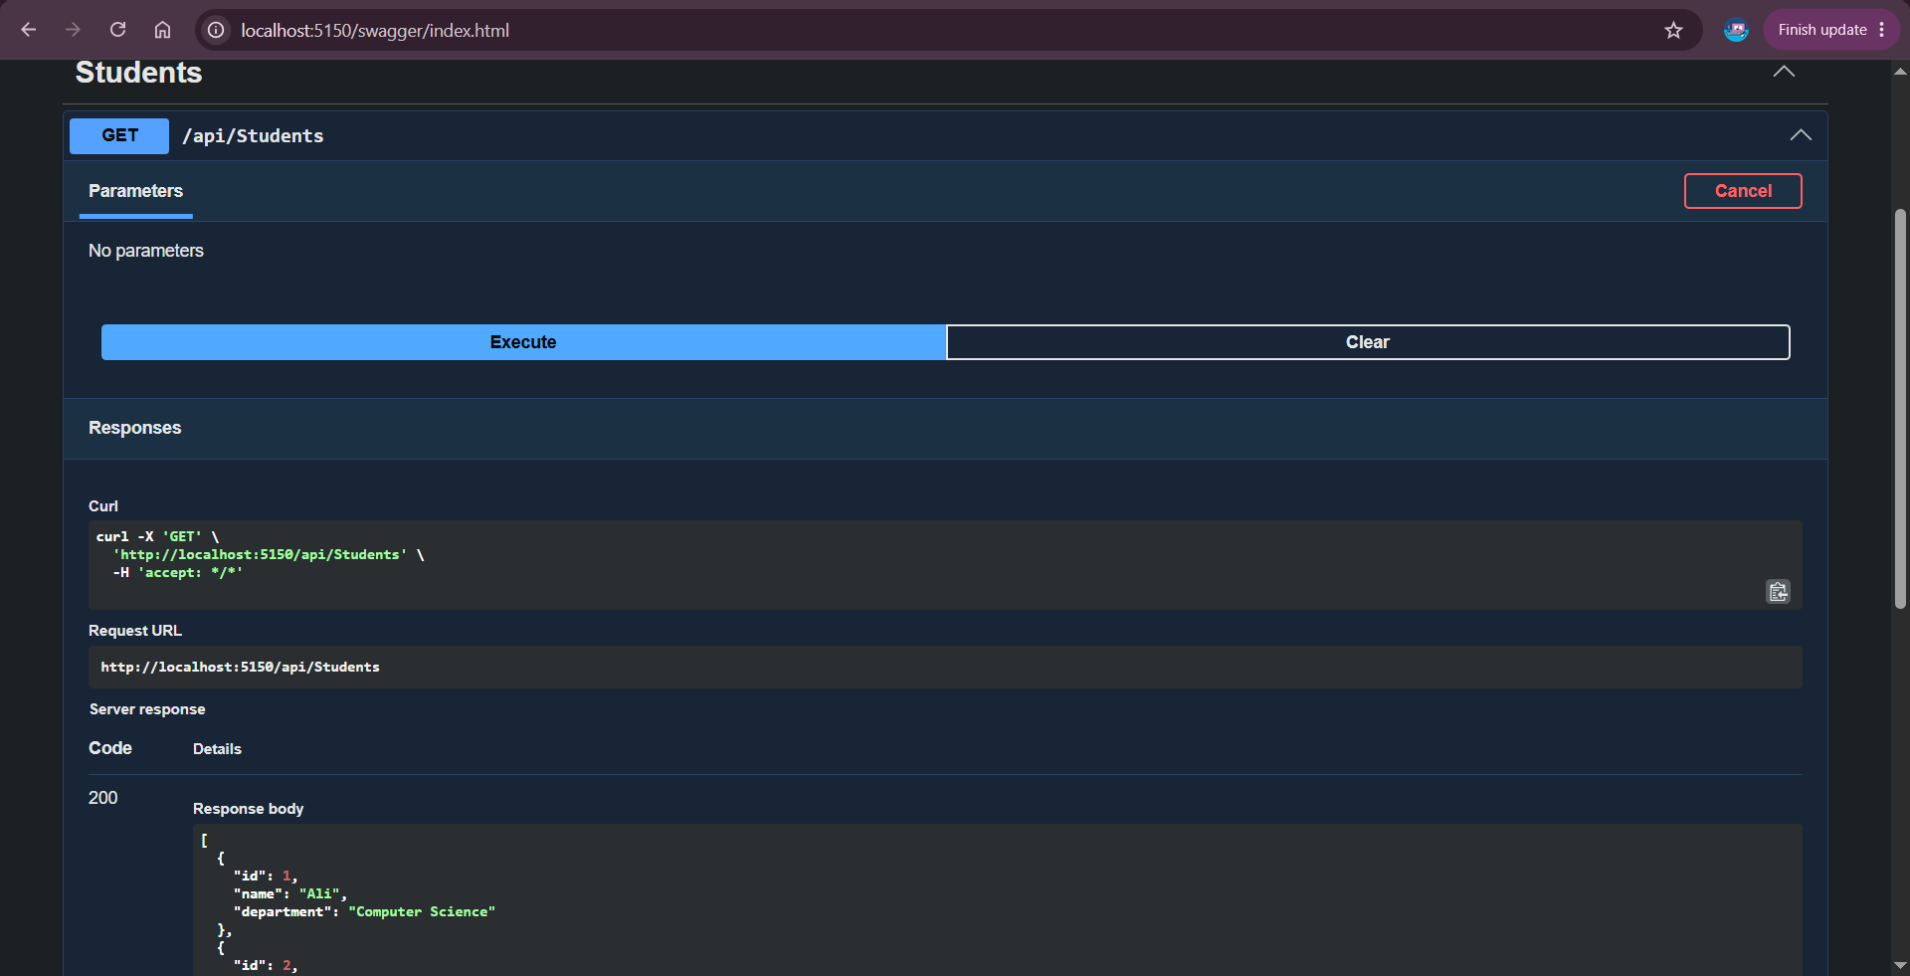
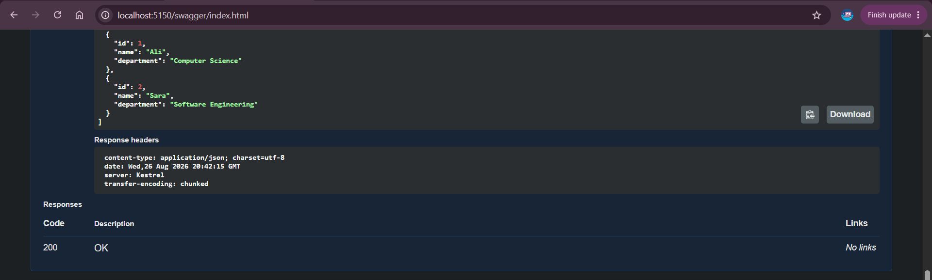

Create a Second Endpoint That Accepts Input
Code:
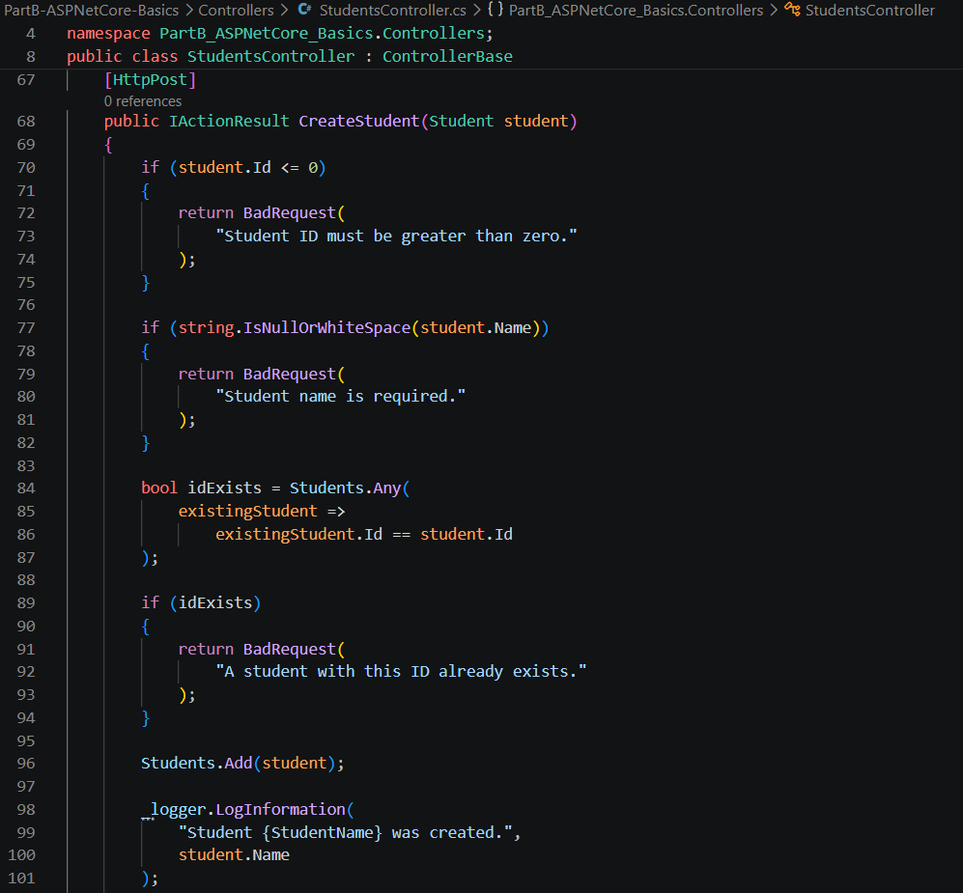

Output:
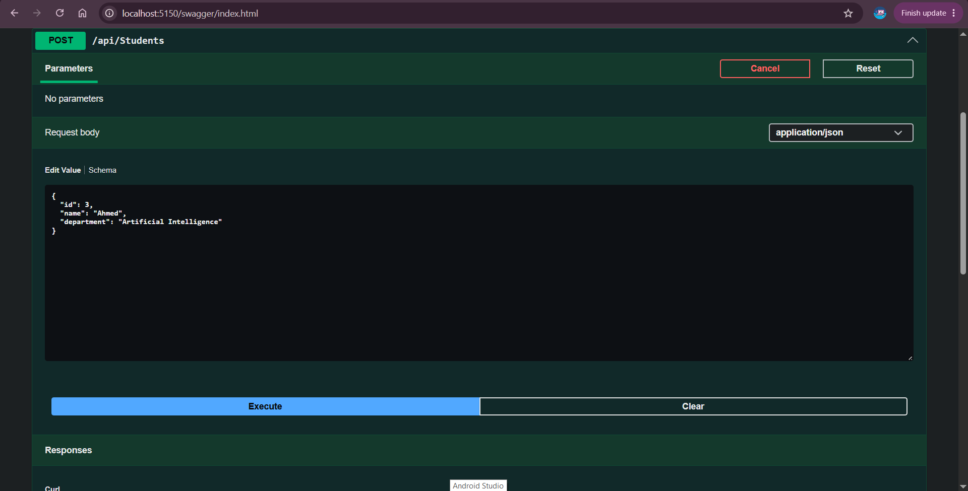
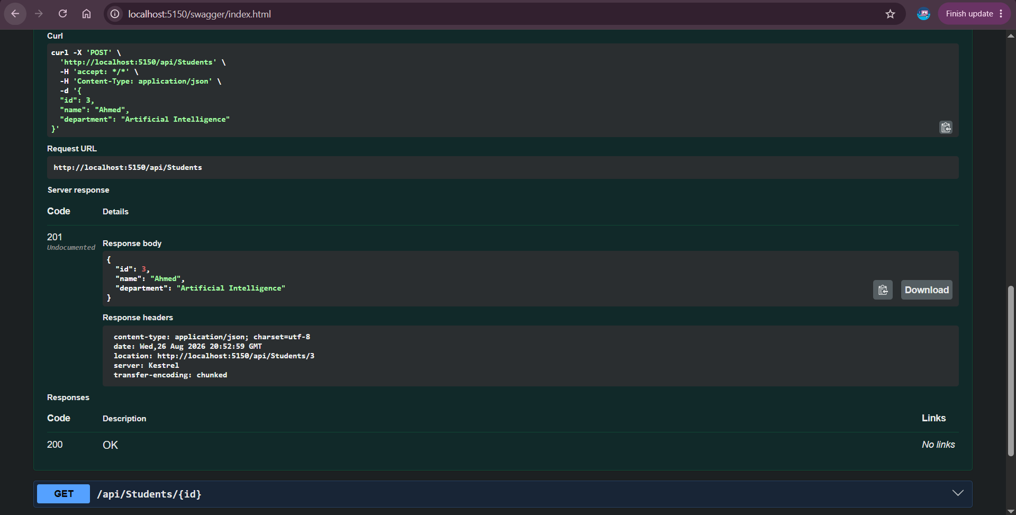

Return Appropriate HTTP Status Codes
Code:

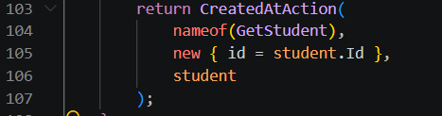
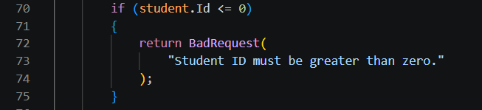
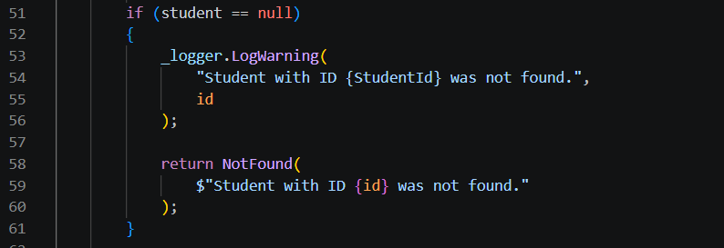
Output:
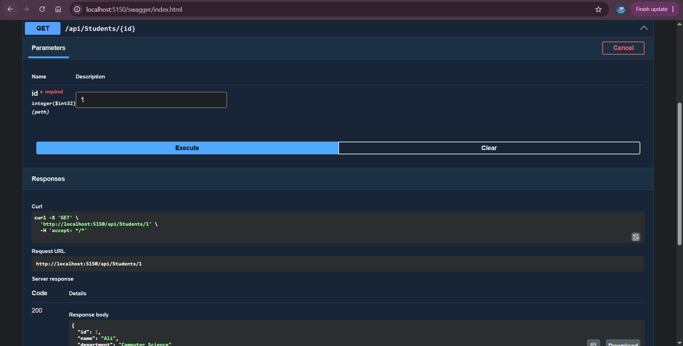
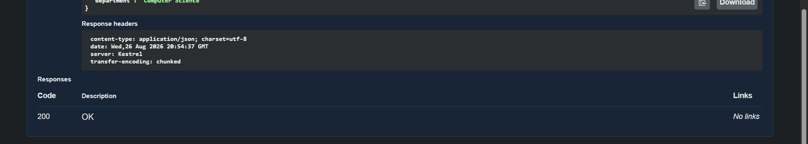


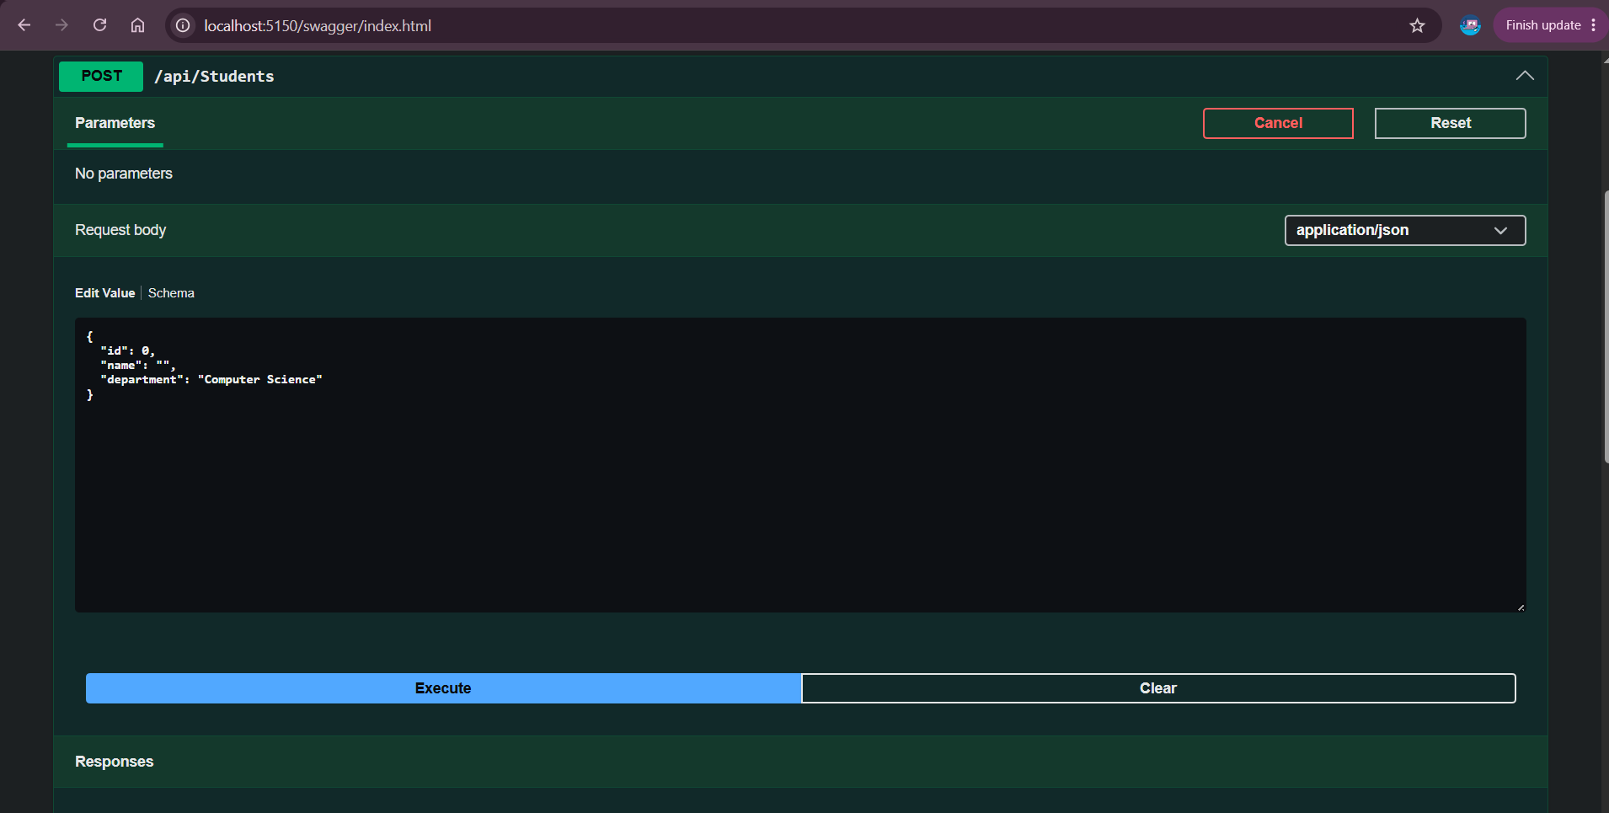
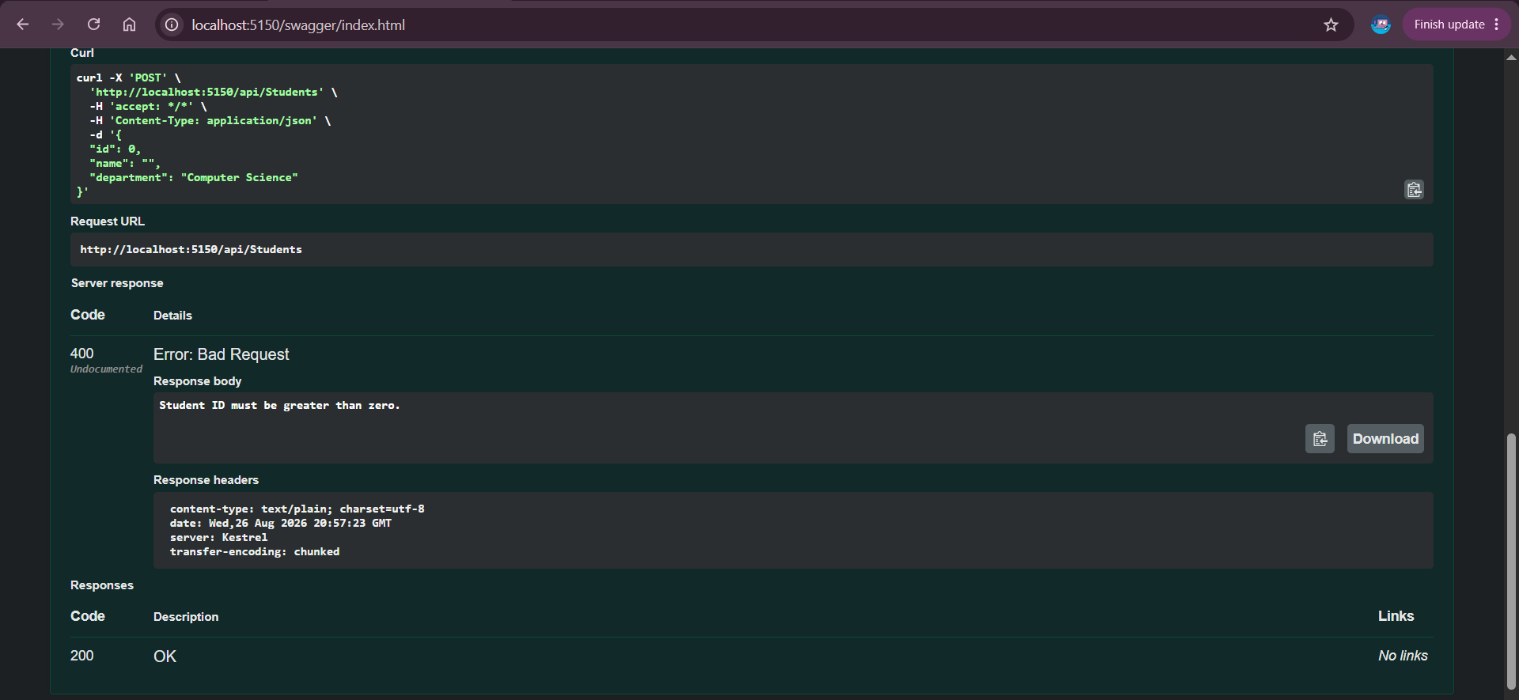
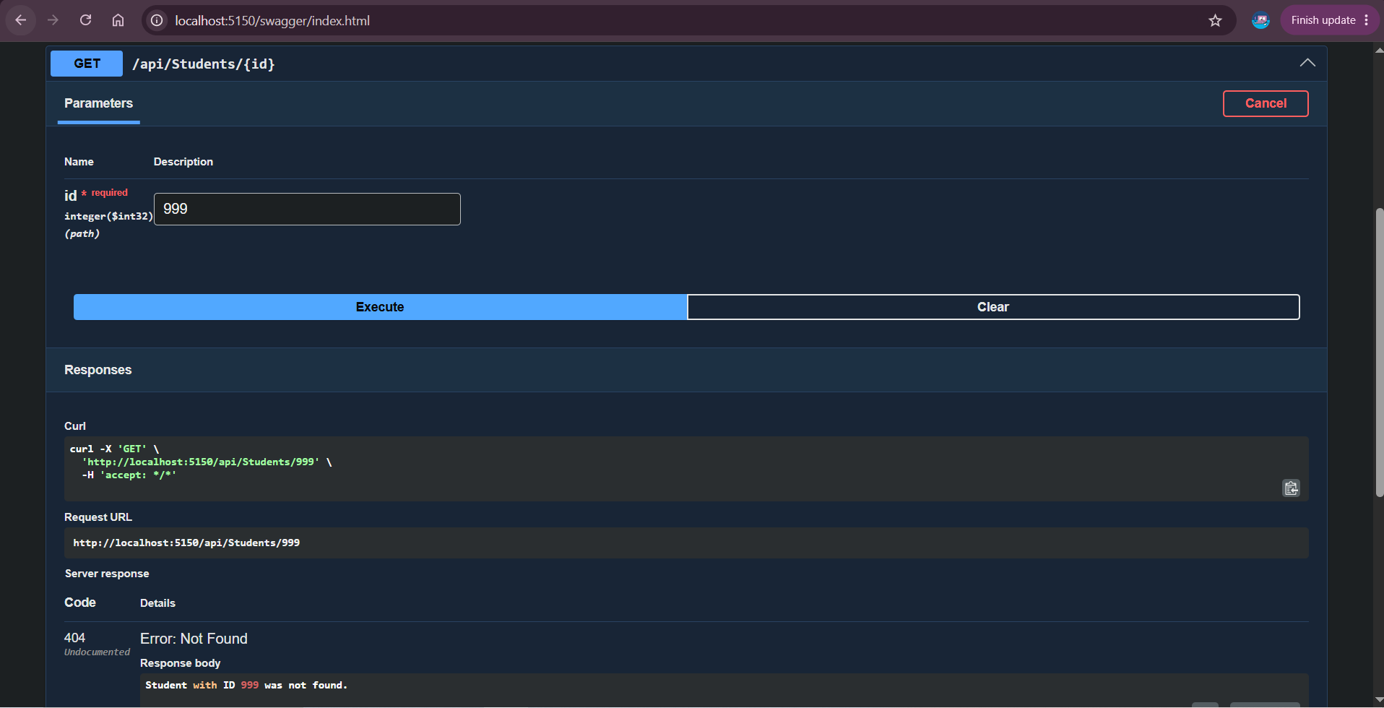
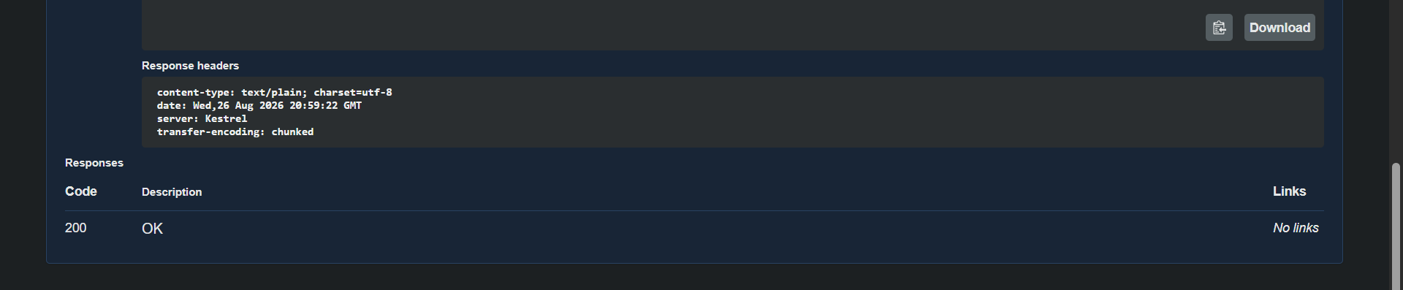

Test Every Endpoint Using Swagger and Postman
Code:
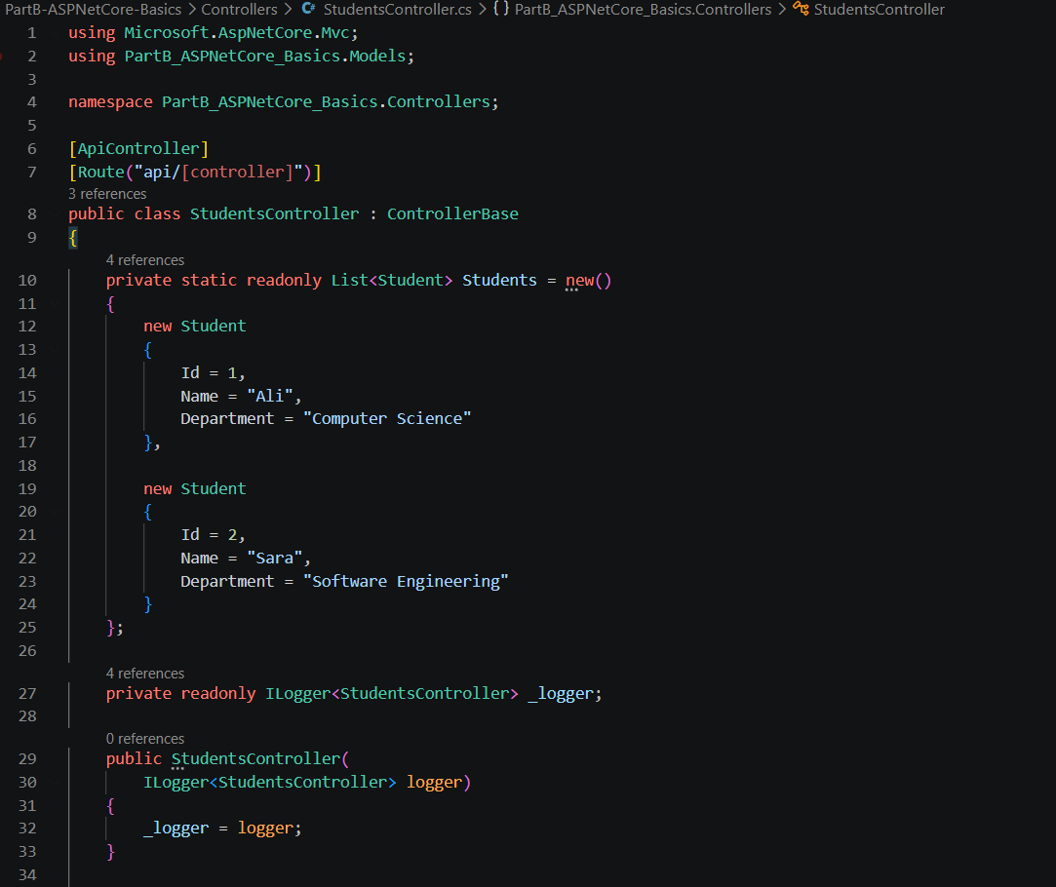
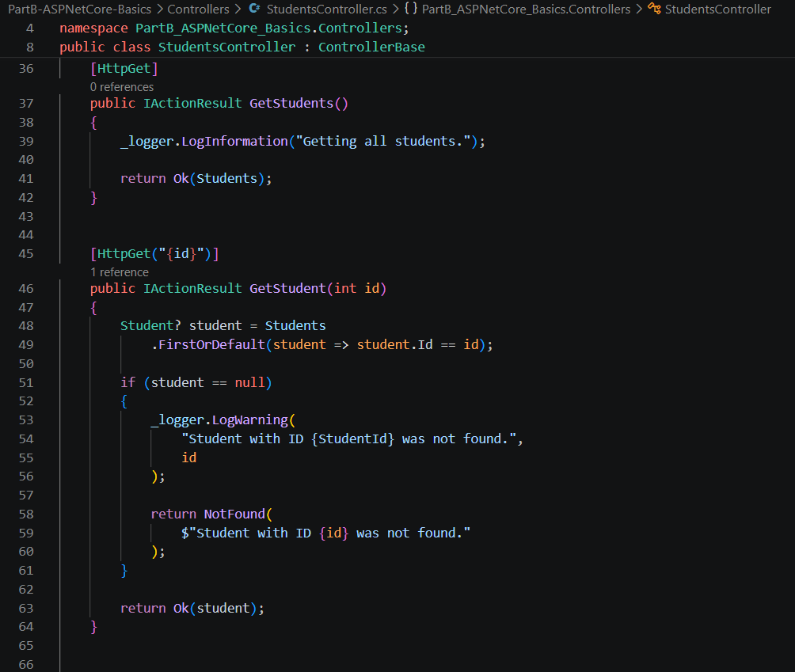
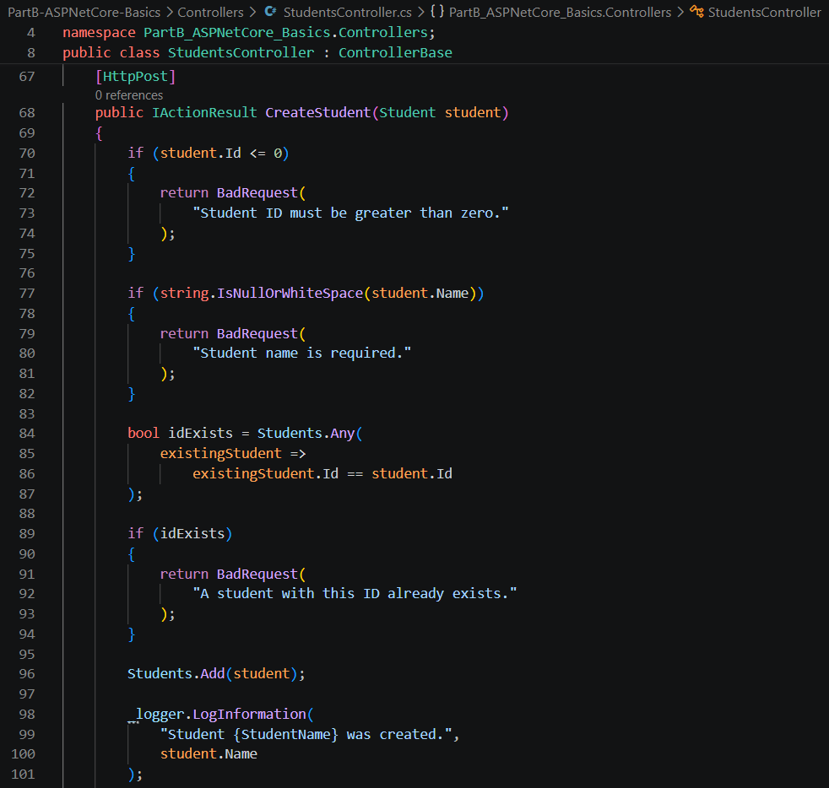
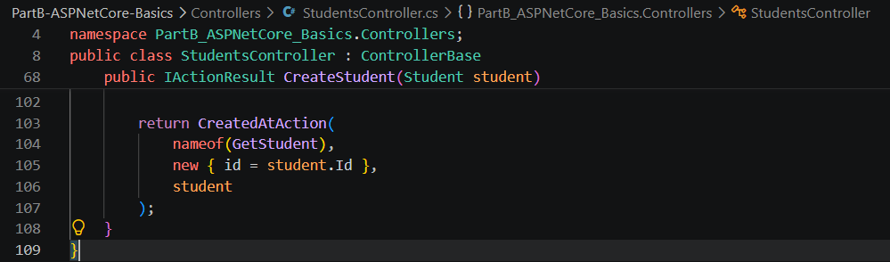
Output:
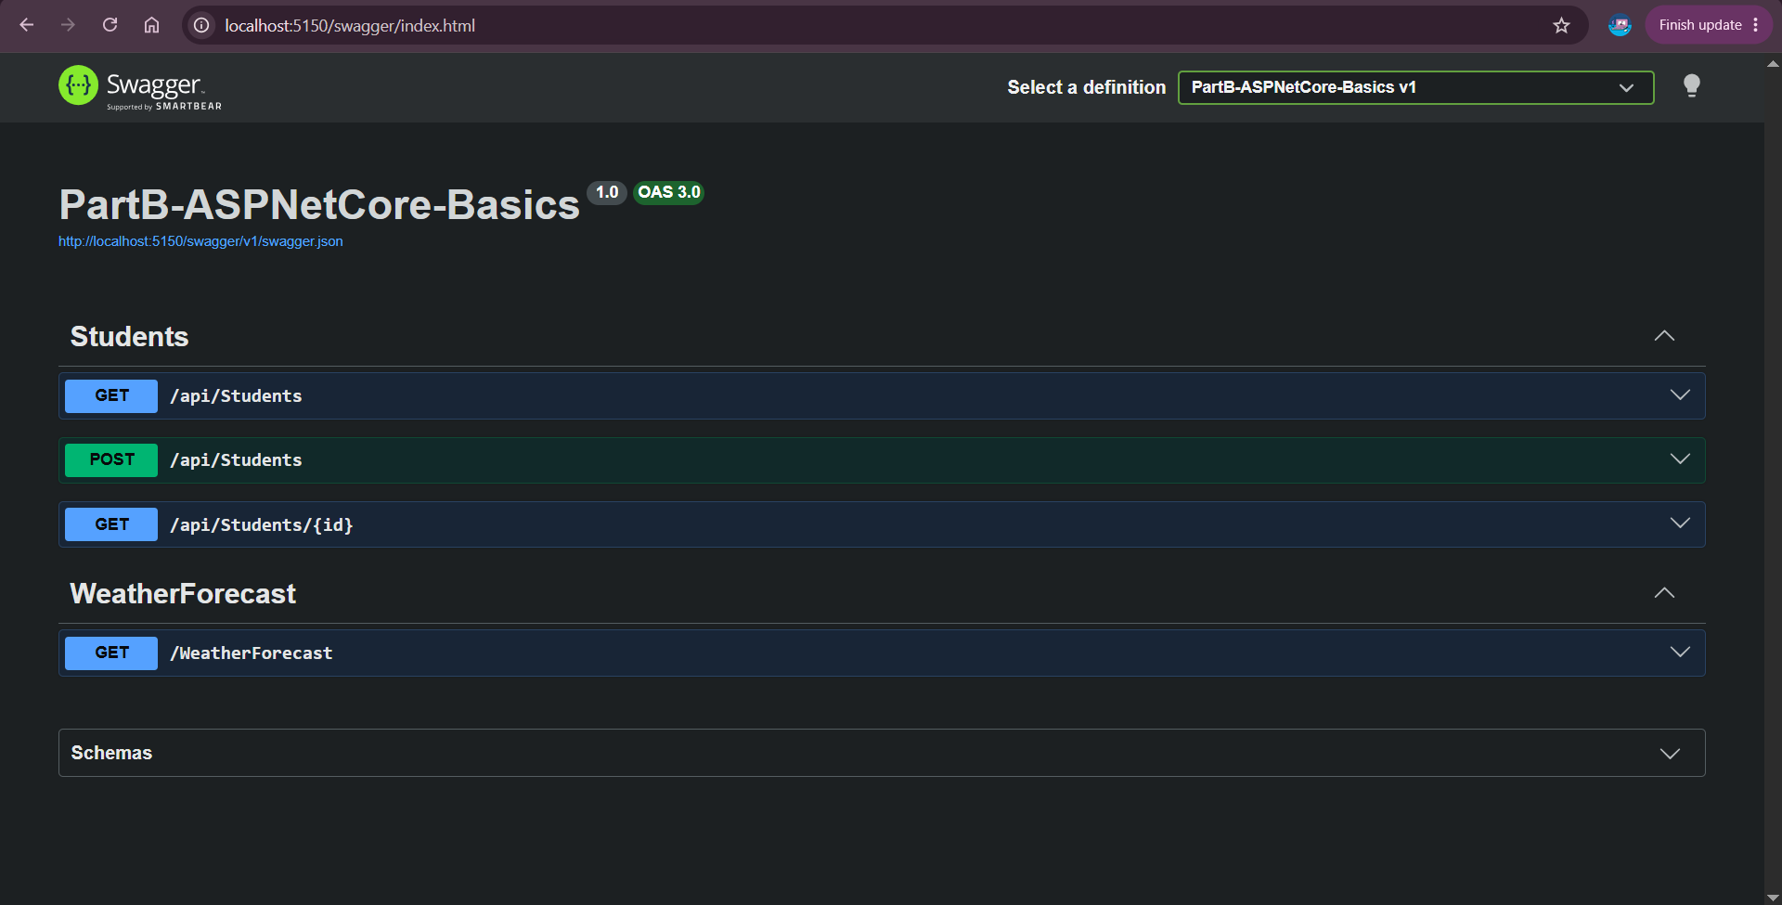

PART C: ARCHITECTURE CONCEPTS

Exercises:-

Controller → Service → Repository → Data Store Diagram
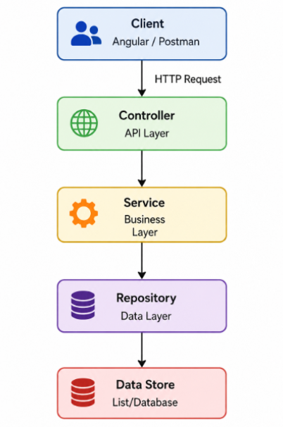

Responsibilities of Each Layer
Controller / Presentation Layer:
The Controller receives HTTP requests from the client and returns HTTP responses. It should handle routing, basic request validation, status codes, and communication with the service layer.
For example;
GET /api/books
↓
BooksController
Service / Business Layer:
The Service contains business logic and application rules. The controller calls the service instead of directly working with the data store.
For example;
BookService could decide whether a book is valid before adding it.
Repository / Data Layer:
The Repository is responsible for reading and writing data. It hides the details of how data is stored from the service and controller.
For example;
BookRepository
↓
List<Book>
Later:
BookRepository
↓
Database
Data Store:
The Data Store is where application data is actually stored.
For example;
List<Book>
for your Week 2 project.
Later:
SQL Server

Why Database Code Should Not Be Placed Directly in Controllers
Putting database code directly inside controllers is poor design because controllers should mainly handle HTTP requests and responses. If database logic is placed in every controller, the code becomes difficult to maintain, test, and reuse. The same database operations may also be repeated in several places. Using a Service and Repository keeps responsibilities separate and makes it easier to change the data source without changing the controller.
For example;
Poor structure:
BooksController
├── HTTP request handling
├── validation
├── business logic
├── database connection
├── SQL queries
└── response handling
The controller is doing too much.
Better structure:
BooksController
↓
BookService
↓
BookRepository
↓
Database
Each class has a clear responsibility.

PART D: ANGULAR BASICS FOR REAL APPLICATIONS

Exercises:-

Create a Reusable StudentService With Mock Data
Code:
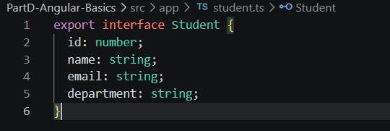
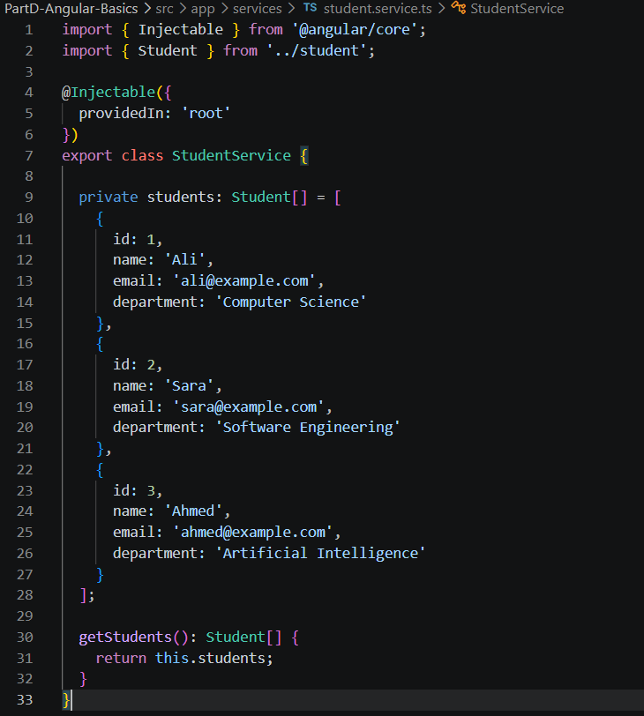
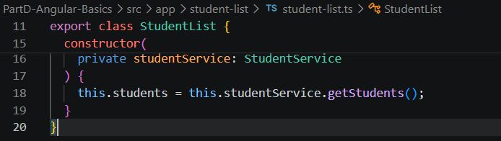
Output:
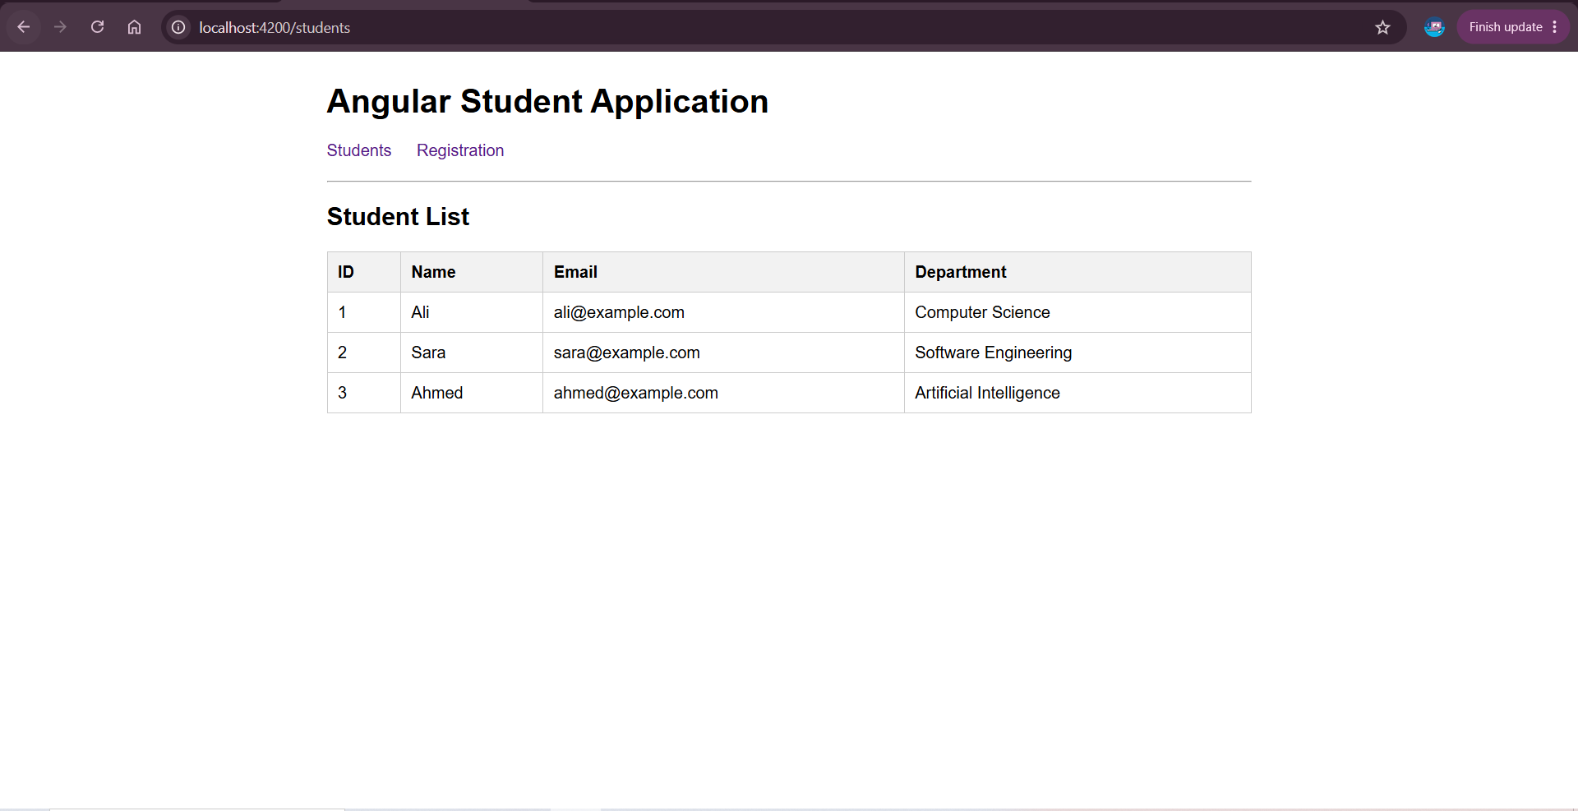

Create a Registration Form Using Reactive Forms
Code:

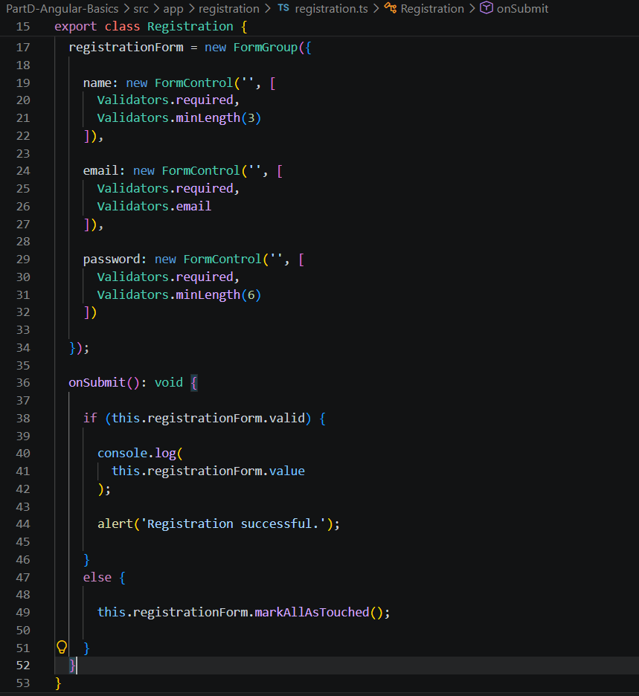
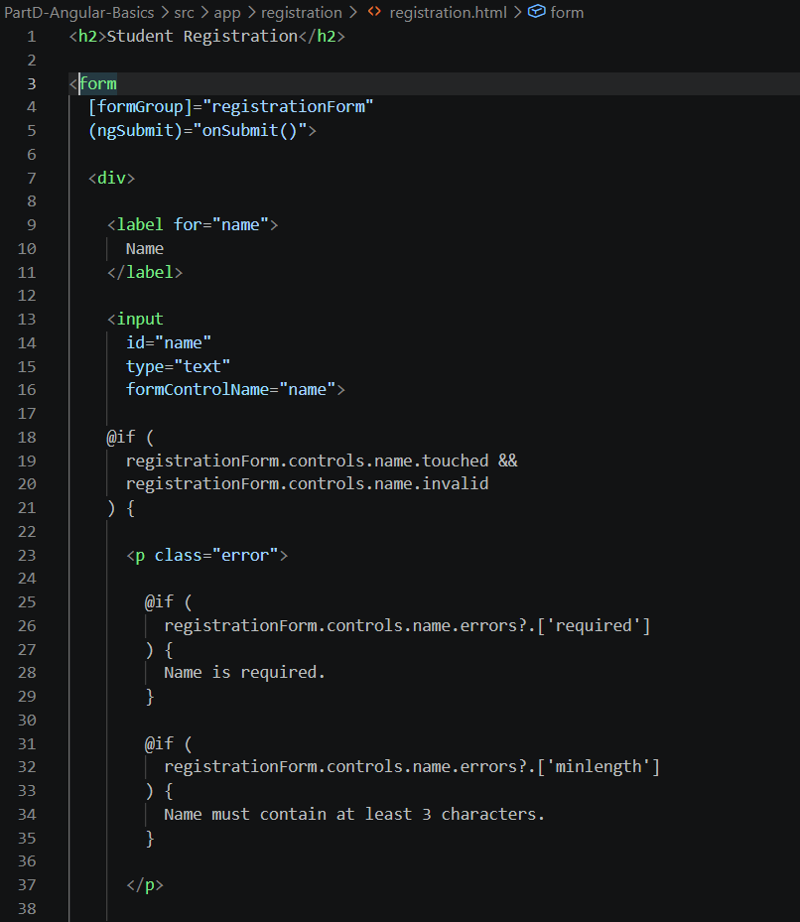
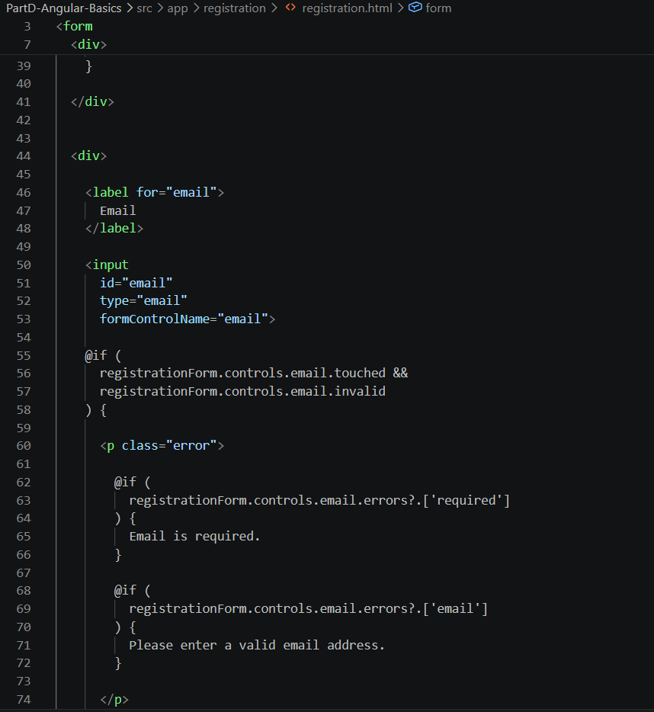
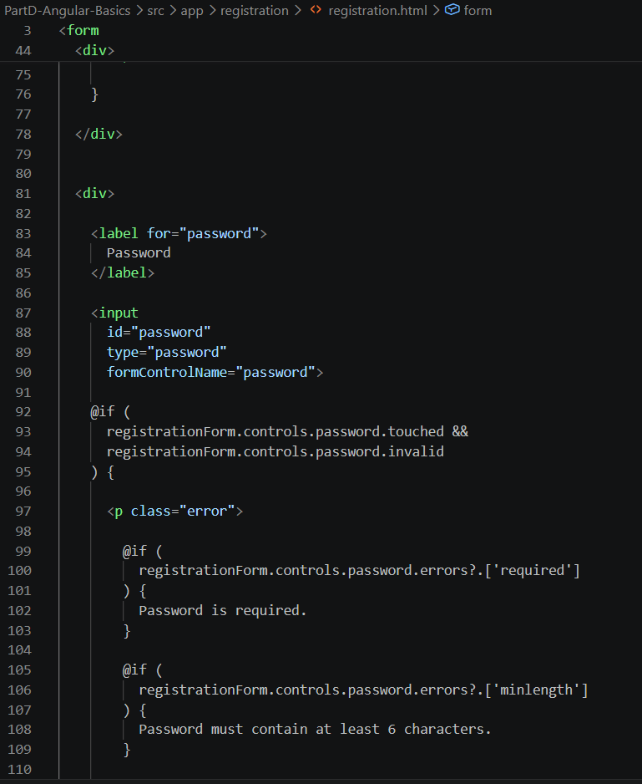
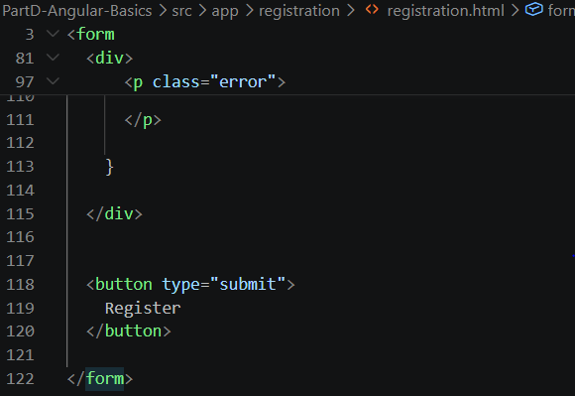
Output:
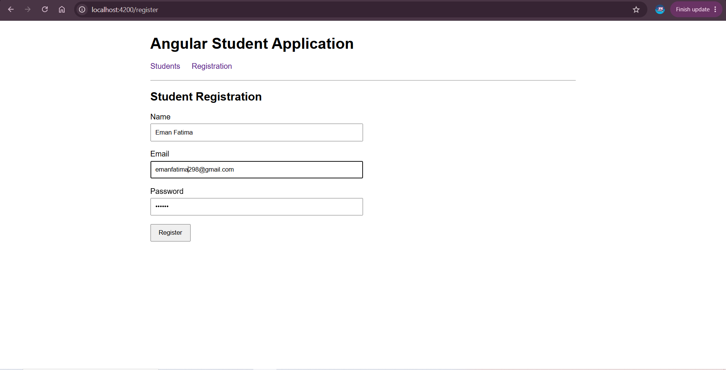
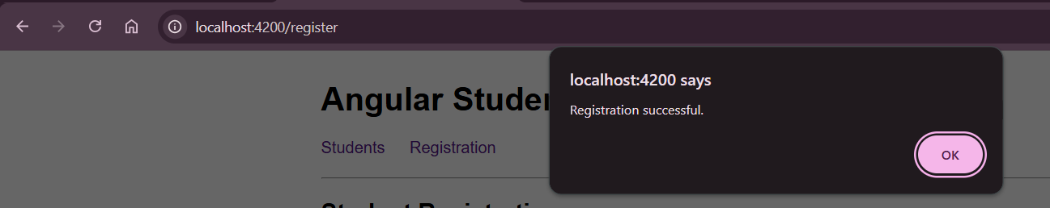

Add Required, Email, and Minimum-Length Validation
Code:
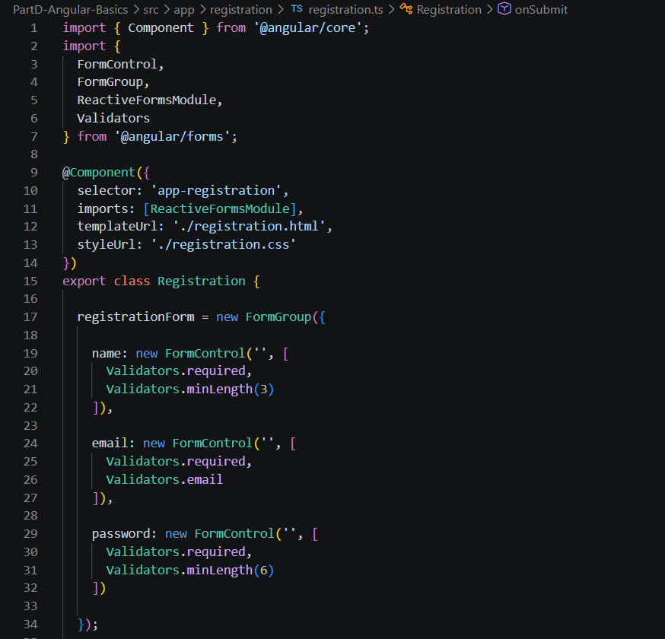
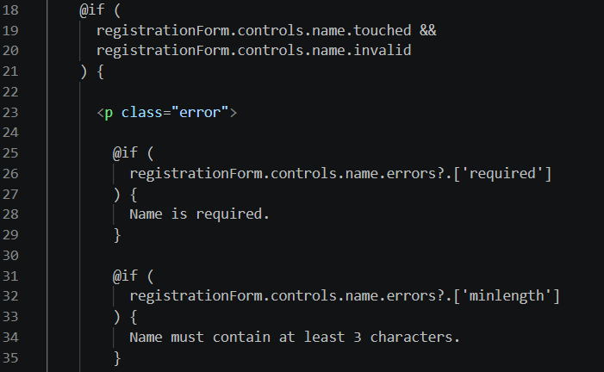
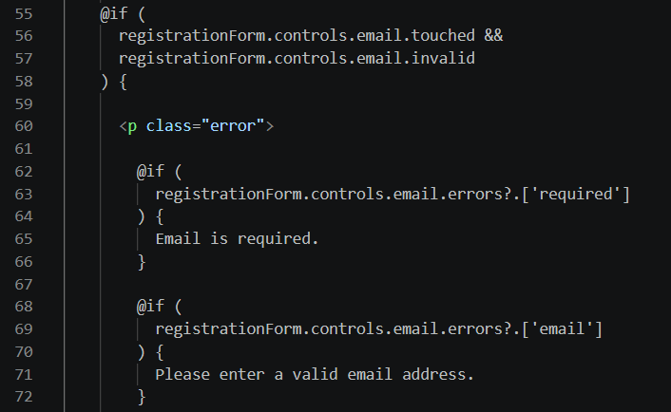
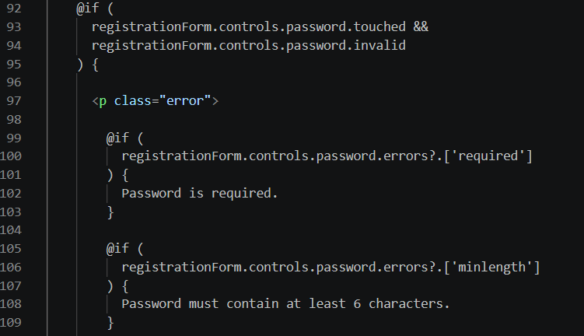
Output:
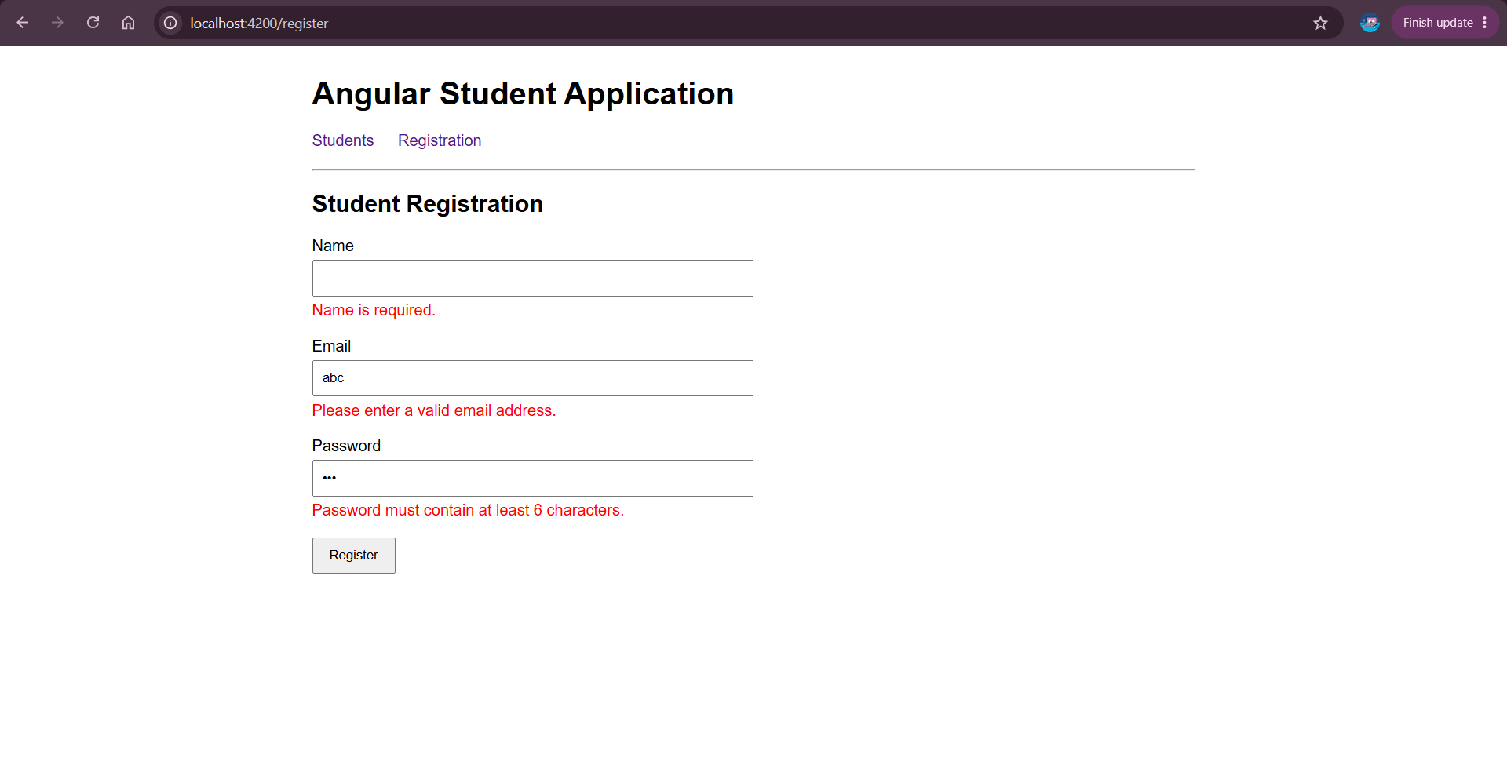

Create Two Routes and Navigate Between Them
Code:
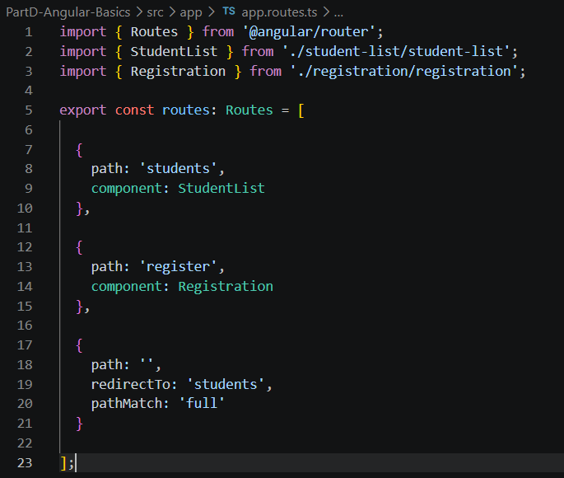
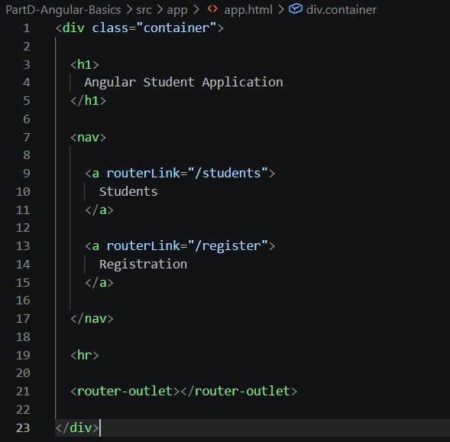
Output:
